SIMATS ENGINEERING
ASSESSMENT TOOL 3

COURSE NAME: Database Management Systems
COURSE CODE: CSA05

COURSE OUTCOME COVERED

CO2: Apply the relational model, relational algebra, SQL query structures, and views to solve database querying and data manipulation problems. (BL3, BL6)

Activity Tool : Debugging & Optimisation Task (Low)
Assessment Tool Weightage: 10%

QUESTIONS
Q.N o | Question | Bloom's Level
1 | Identify and correct errors in a given SQL CREATE TABLE statement with incorrect syntax and missing constraints. | BL2 –  Understand
2 | Debug an SQL query that incorrectly uses aggregate functions without GROUP BY and fix the issue. Bloom’s Level: | BL2 –  Understand
3 | Correct a faulty SELECT query where column names are misspelled or improperly referenced. | BL1 –  Remember
4 | Fix errors in an SQL query using JOIN, where the join condition is missing or incorrect. | BL3 – Apply
5 | Identify and correct a subquery error where multiple values are returned instead of a single value. | BL2 –  Understand
6 | Debug a VIEW creation statement that contains invalid column references or syntax errors. | BL1 –  Remember
7 | Examine an SQL query with unnecessary conditions and optimize it by simplifying the WHERE clause. | BL3 – Apply
8 | Identify violations of integrity constraints in a given table and correct them. | BL2 –  Understand
9 | Fix a relation that violates 1NF or 2NF by removing repeating groups or partial dependencies. | BL3 – Apply
10 | Identify redundant attributes in a relation and apply basic normalization (up to 3NF) to improve design. | BL3 – Apply

Code of Conduct:

Criteria | Level 4 (Exemplary) | Level 3 (Proficient) | Level 2 (Developing) | Level 1 (Beginning)
Problem  Identification | Accurately  identifies all errors and  root causes with clear understanding | Identifies most errors with minor gaps | Identifies some errors  but misses key issues | Unable to identify errors correctly
Debugging | Applies systematic debugging  techniques  effectively to resolve issues | Uses appropriate debugging  methods with minor errors | Limited debugging approach; requires guidance | Unable to debug or resolve issues
Optimization | Optimizes code by  significantly  improving time  complexity  using efficient algorithms | Improves time complexity with  minor gaps in efficiency | Limited improvement in time complexity | No improvement; inefficient approach retained
Analysis | Demonstrates strong logical  reasoning and clear  justification of solutions | Shows reasonable  analysis with some  justification | Limited analysis; weak reasoning | No analytical reasoning demonstrated
Code Quality | Produces clean,  well-structure  d code with proper  comments and | Code is mostly clear with minor  documentation gaps | Code lacks structure and proper  documentation | Poorly written code with no documentation

I DHANUSHYA RB(192565033) certify that this submission is my original work and that I have adhered to the guidelines specified for this assessment. I understand that any violation of academic integrity rules will result in disciplinary action.

Signature of the student:
DHANUSHYA RB

RUBRICS FOR CALCULATION:

 | correct final answer
Interpretation of Results | Clearly interprets  results with units and  engineering relevance | Basic interpretatio  n with minor omissions | Limited or unclear interpretation | No  interpretatio n

1.Identify and correct errors in a given SQL CREATE TABLE statement with incorrect syntax and missing constraints.

Incorrect SQL Query
CREATE TABLE STUDENT
(
Student_ID INT
Student_Name VARCHAR(50),
Department_ID INT,
CGPA DECIMAL(3,2),
PRIMARY Student_ID,
FOREIGN KEY Department_ID REFERENCES DEPARTMENT(Department_ID)
);

Errors Identified
- Missing comma after Student_ID INT.
- Incorrect syntax for Primary Key (PRIMARY Student_ID).
- Incorrect syntax for Foreign Key (FOREIGN KEY Department_ID).
- Student_ID should be declared as NOT NULL since it is the Primary Key.
- Department_ID should reference the DEPARTMENT table using proper SQL syntax.
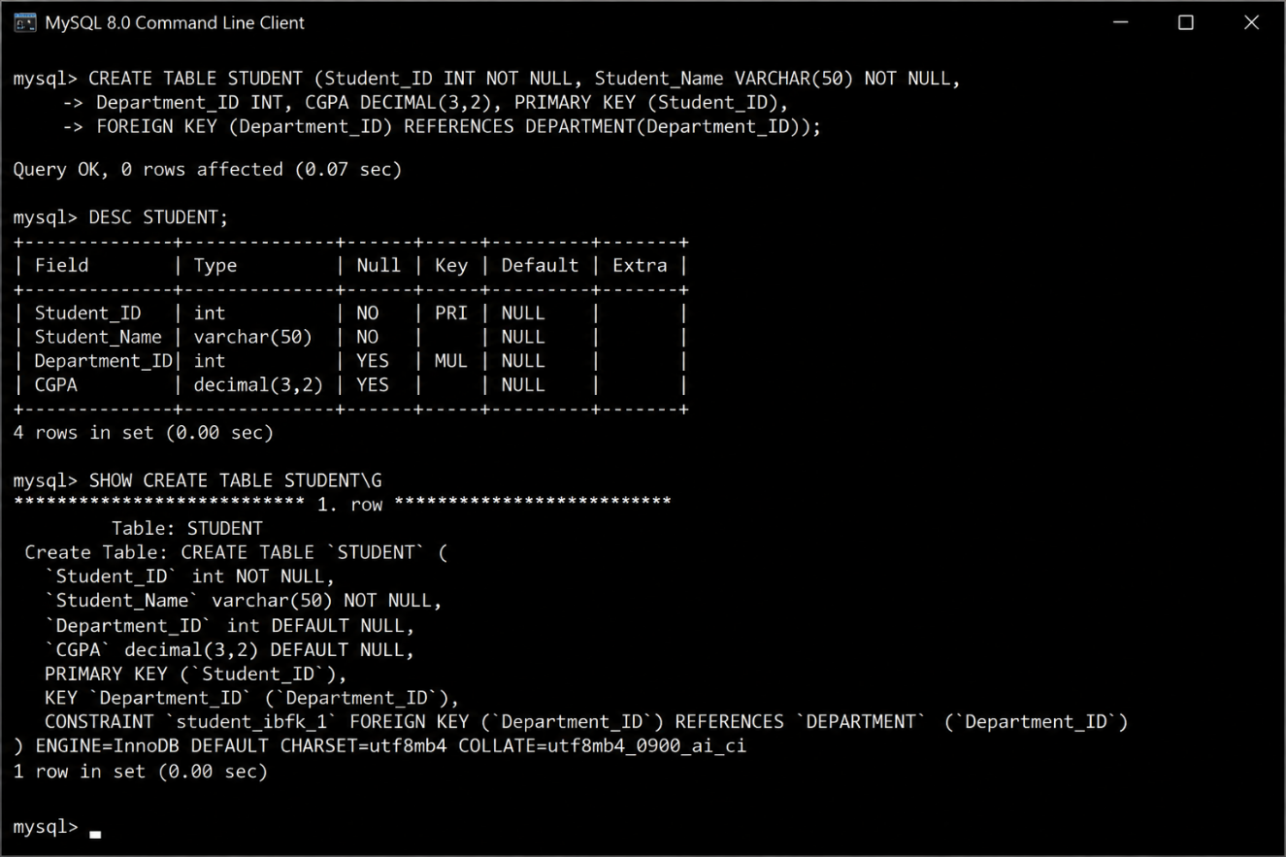

Final Correct Query
CREATE TABLE STUDENT
(
Student_ID INT NOT NULL,
Student_Name VARCHAR(50) NOT NULL,
Department_ID INT,
CGPA DECIMAL(3,2),
PRIMARY KEY (Student_ID),
FOREIGN KEY (Department_ID) REFERENCES DEPARTMENT(Department_ID)
);
Expected Result:
Message
Query OK, 0 rows affected
Table STUDENT created successfully

2.Debug an SQL query that incorrectly uses aggregate functions without GROUP BY and fix the issue.

Incorrect SQL Query
SELECT Department_ID, AVG(CGPA)
FROM STUDENT;

Errors Identified
- The aggregate function AVG() is used along with a non-aggregated column (Department_ID).
- The GROUP BY clause is missing.
- SQL cannot determine how to calculate the average CGPA for each department without grouping the records.

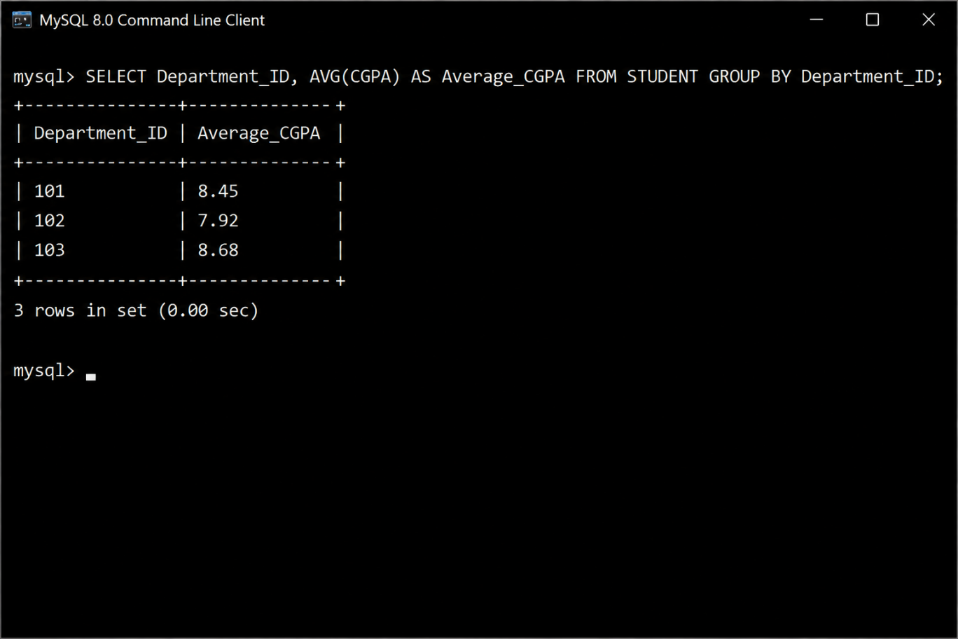

Explanation
- AVG(CGPA) calculates the average CGPA.
- GROUP BY Department_ID groups all students belonging to the same department before calculating the average.
- The alias Average_CGPA makes the output column easier to understand.

Final Correct Query
SELECT Department_ID, AVG(CGPA) AS Average_CGPA
FROM STUDENT
GROUP BY Department_ID;
Expected Result
+---------------+--------------+
| Department_ID | Average_CGPA |
+---------------+--------------+
| 101 | 8.45 |
| 102 | 7.92 |
| 103 | 8.68 |
+---------------+--------------+
Result: The query executes successfully and displays the average CGPA for each department.

3.Correct a faulty SELECT query where column names are misspelled or improperly referenced.
Incorrect SQL Query
SELECT Student_Nam, Departmnt_ID, CGPA
FROM STUDENT;

Errors Identified
- The column name Student_Nam is misspelled. It should be Student_Name.
- The column name Departmnt_ID is misspelled. It should be Department_ID.
- Due to the incorrect column names, the query will result in an Unknown column error.

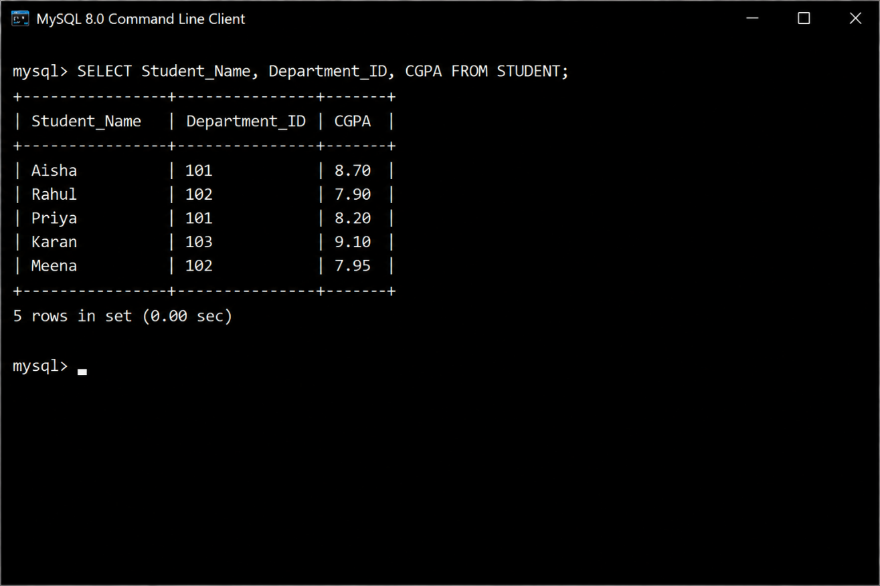

Explanation
- The SELECT statement must reference valid column names that exist in the STUDENT table.
- Correcting the spelling of Student_Name and Department_ID allows the query to execute successfully.
- The query retrieves the student name, department ID, and CGPA from the STUDENT table.

Final Correct Query
SELECT Student_Name, Department_ID, CGPA
FROM STUDENT;
Expected Result
+--------------+---------------+------+
| Student_Name | Department_ID | CGPA |
+--------------+---------------+------+
| Aisha | 101 | 8.70 |
| Rahul | 102 | 7.90 |
| Priya | 101 | 8.20 |
| Karan | 103 | 9.10 |
| Meena | 102 | 7.95 |
+--------------+---------------+------+
Result: The query executes successfully and displays the student name, department ID, and CGPA for all students.

4.Fix errors in an SQL query using JOIN, where the join condition is missing or incorrect.

Incorrect SQL Query
SELECT S.Student_Name, D.Department_Name
FROM STUDENT S
INNER JOIN DEPARTMENT D;

Errors Identified
- The INNER JOIN statement is missing the ON clause.
- Without the join condition, SQL does not know how to match records from the STUDENT and DEPARTMENT tables.
- The join should be performed using the common column Department_ID.

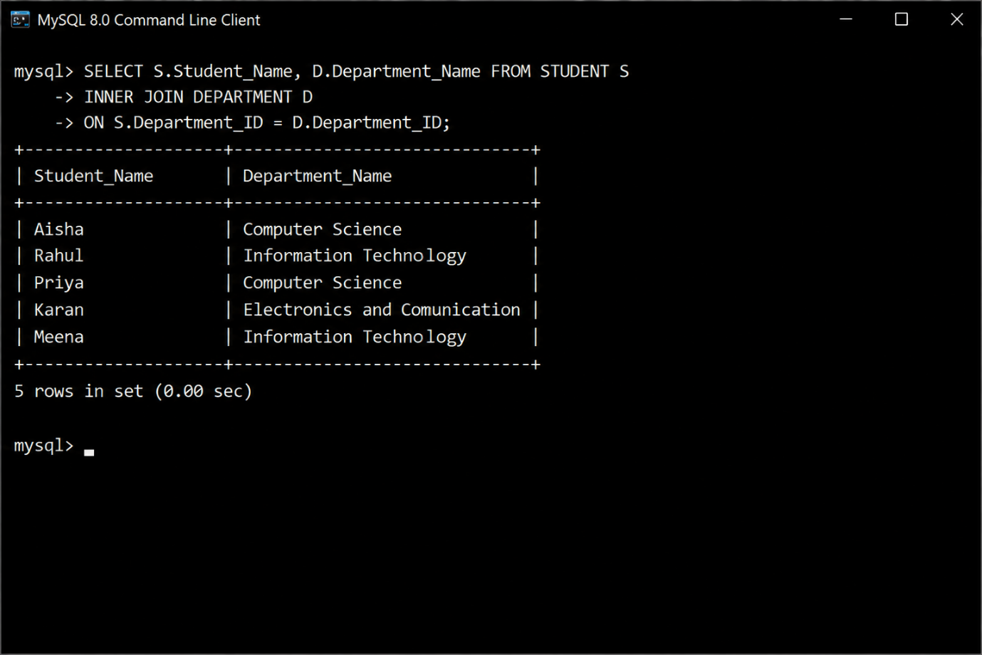

Explanation
- INNER JOIN combines rows from both tables based on a matching condition.
- The ON clause specifies that Department_ID in the STUDENT table must match Department_ID in the DEPARTMENT table.
- Only matching records from both tables are returned.

Final Correct Query
SELECT S.Student_Name, D.Department_Name
FROM STUDENT S
INNER JOIN DEPARTMENT D
ON S.Department_ID = D.Department_ID;
Expected Result
+--------------+--------------------------------+
| Student_Name | Department_Name |
+--------------+--------------------------------+
| Aisha | Computer Science |
| Rahul | Information Technology |
| Priya | Computer Science |
| Karan | Electronics and Communication |
| Meena | Information Technology |
+--------------+--------------------------------+
Result: The query executes successfully and displays each student's name along with their corresponding department name by correctly joining the STUDENT and DEPARTMENT tables.

5.Identify and correct a subquery error where multiple values are returned instead of a single value.
Incorrect SQL Query
SELECT Student_Name
FROM STUDENT
WHERE Department_ID =
(
SELECT Department_ID
FROM DEPARTMENT
WHERE Department_Name LIKE '%Technology%'
);

Errors Identified
- The subquery returns multiple Department_ID values (for example, Information Technology and Technology Management).
- The = operator expects only one value, but the subquery returns multiple rows.
- Use the IN operator when the subquery returns multiple values.

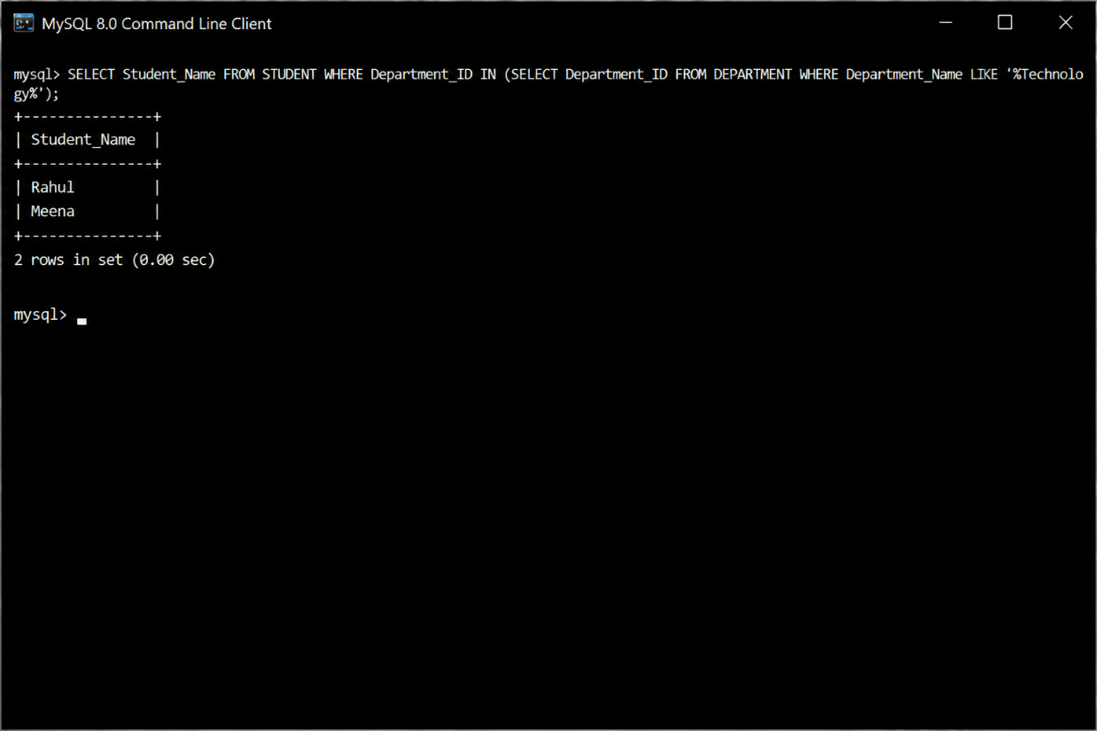

Explanation
- The subquery retrieves all Department_ID values whose department names contain the word Technology.
- Since multiple department IDs may be returned, the IN operator is used instead of =.
- This allows the main query to display all students belonging to those departments.

Final Correct Query
SELECT Student_Name
FROM STUDENT
WHERE Department_ID IN
(
SELECT Department_ID
FROM DEPARTMENT
WHERE Department_Name LIKE '%Technology%'
);
Expected Result
+--------------+
| Student_Name |
+--------------+
| Rahul |
| Meena |
+--------------+
Result: The query executes successfully and displays the names of students who belong to departments whose names contain the word Technology.

6.Debug a VIEW creation statement that contains invalid column references or syntax errors.

Incorrect SQL Query
CREATE VIEW Faculty_View AS
SELECT
S.Student_Nam,
D.Dept_Name
FROM STUDENT S
INNER JOIN DEPARTMENT D
ON S.Department_ID = D.Department_ID;

Errors Identified
- Student_Nam is an invalid column name. It should be Student_Name.
- Dept_Name is an invalid column name. It should be Department_Name.
- The view cannot be created because the referenced column names do not exist.

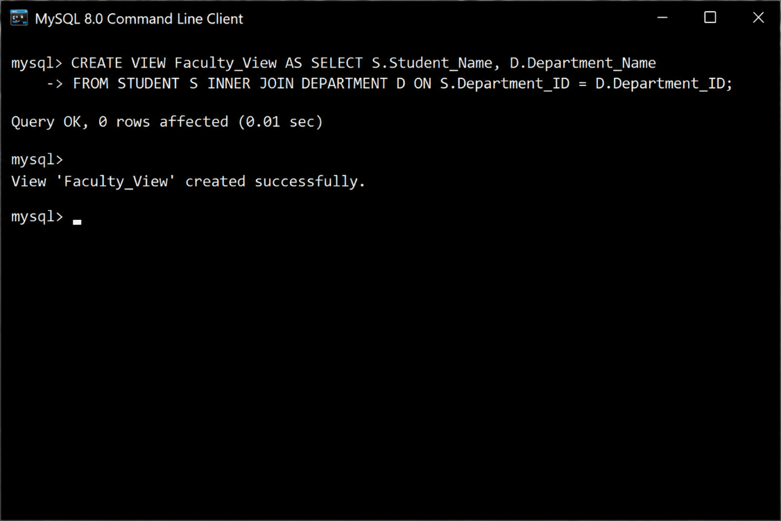

Explanation
- The CREATE VIEW statement creates a virtual table based on the result of the SELECT query.
- The column names must exactly match the column names in the STUDENT and DEPARTMENT tables.
- After correcting Student_Name and Department_Name, the view is created successfully.

Final Correct Query
CREATE VIEW Faculty_View AS
SELECT
S.Student_Name,
D.Department_Name
FROM STUDENT S
INNER JOIN DEPARTMENT D
ON S.Department_ID = D.Department_ID;
Expected Result
Message
Query OK, 0 rows affected
View Faculty_View created successfully

7.Examine an SQL query with unnecessary conditions and optimize it by simplifying the WHERE clause.

Incorrect SQL Query
SELECT Student_Name, CGPA
FROM STUDENT
WHERE CGPA > 7.5
AND CGPA > 6.0
AND Department_ID = 101
AND Department_ID = 101;

Errors Identified
- The condition CGPA > 6.0 is unnecessary because CGPA > 7.5 already satisfies it.
- The condition Department_ID = 101 is repeated.
- Removing redundant conditions makes the query simpler and more efficient.
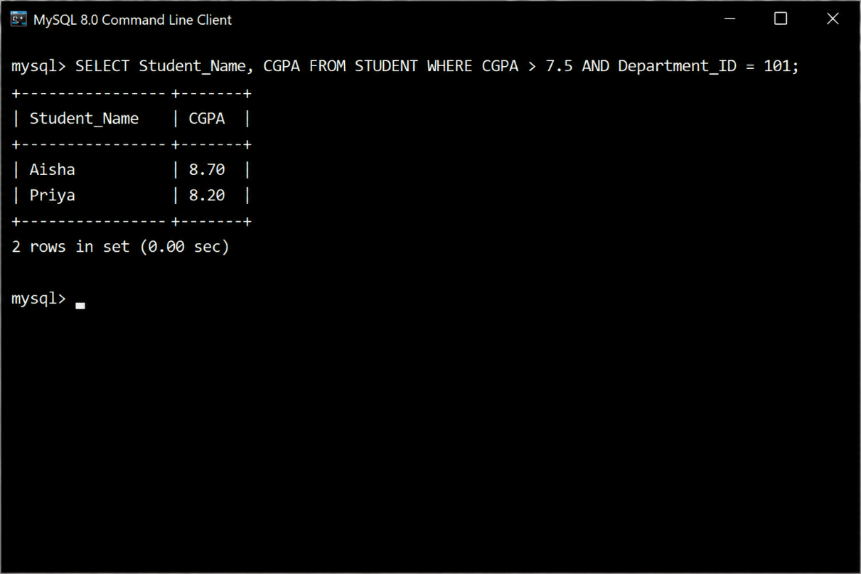

Explanation
- The condition CGPA > 7.5 already excludes values less than or equal to 7.5, making CGPA > 6.0 unnecessary.
- Repeating Department_ID = 101 has no effect on the result.
- The optimized query is shorter, easier to read, and performs the same operation.

Final Correct Query
SELECT Student_Name, CGPA
FROM STUDENT
WHERE CGPA > 7.5
AND Department_ID = 101;
Expected Result
+--------------+------+
| Student_Name | CGPA |
+--------------+------+
| Aisha | 8.70 |
| Priya | 8.20 |
+--------------+------+
Result: The query executes successfully and returns students from Department 101 whose CGPA is greater than 7.5, with unnecessary conditions removed.

8.Identify violations of integrity constraints in a given table and correct them.

Incorrect SQL Query
INSERT INTO STUDENT (Student_ID, Student_Name, Department_ID, CGPA)
VALUES
(NULL, 'Aisha', 101, 8.70),
(102, 'Rahul', 999, 7.90);

Errors Identified
- Student_ID is NULL, which violates the PRIMARY KEY and NOT NULL constraints.
- Department_ID = 999 does not exist in the DEPARTMENT table, violating the FOREIGN KEY constraint.
- The data must satisfy all integrity constraints before insertion.

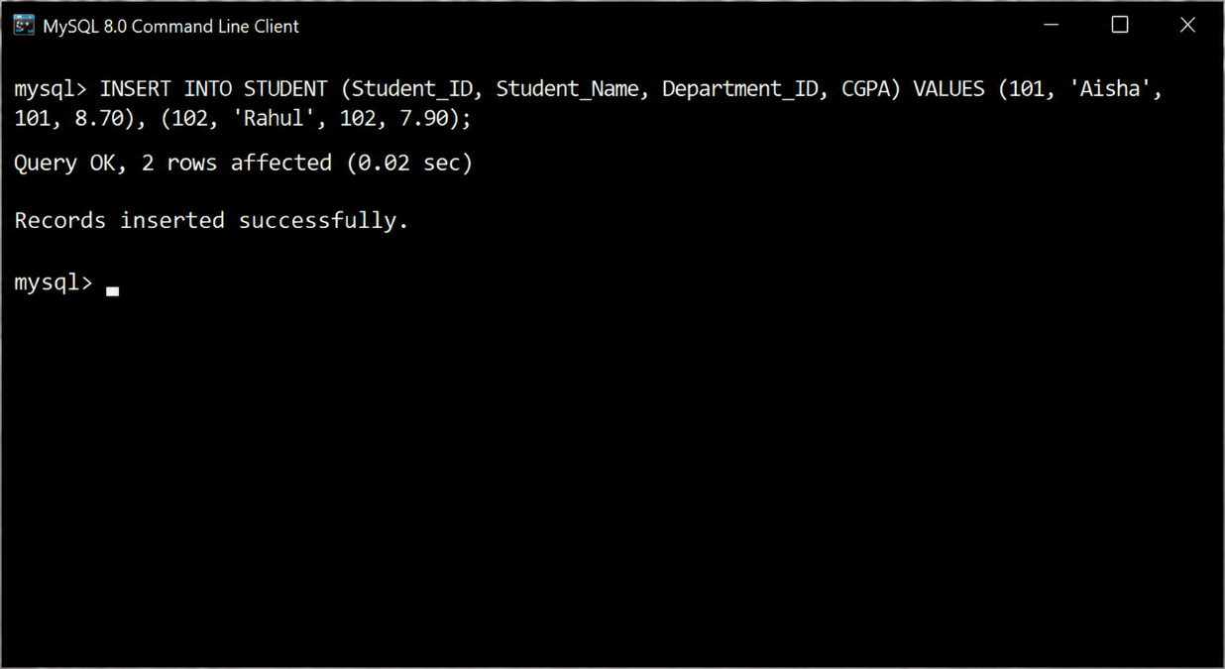

Explanation
- Every Primary Key must contain a unique, non-NULL value.
- Every Foreign Key value must match an existing value in the referenced table (DEPARTMENT).
- After assigning a valid Student_ID and an existing Department_ID, the records are inserted successfully.

Final Correct Query
INSERT INTO STUDENT (Student_ID, Student_Name, Department_ID, CGPA)
VALUES
(101, 'Aisha', 101, 8.70),
(102, 'Rahul', 102, 7.90);
Expected Result
Message
Query OK, 2 rows affected
Records inserted successfully

9.Fix a relation that violates 1NF or 2NF by removing repeating groups or partial dependencies.

Given Relation (Violates 1NF)
Student_ID | Student_Name | Course_Names
101 | Aisha | DBMS, Java
102 | Rahul | Python, C++, SQL

Errors Identified
- The attribute Course_Names contains multiple values in a single column.
- This violates the First Normal Form (1NF), which requires each attribute to contain only atomic (single) values.
- Repeating groups should be removed by creating separate rows for each course.

SQL Implementation
Incorrect Table
CREATE TABLE STUDENT
(
Student_ID INT,
Student_Name VARCHAR(50),
Course_Names VARCHAR(100)
);

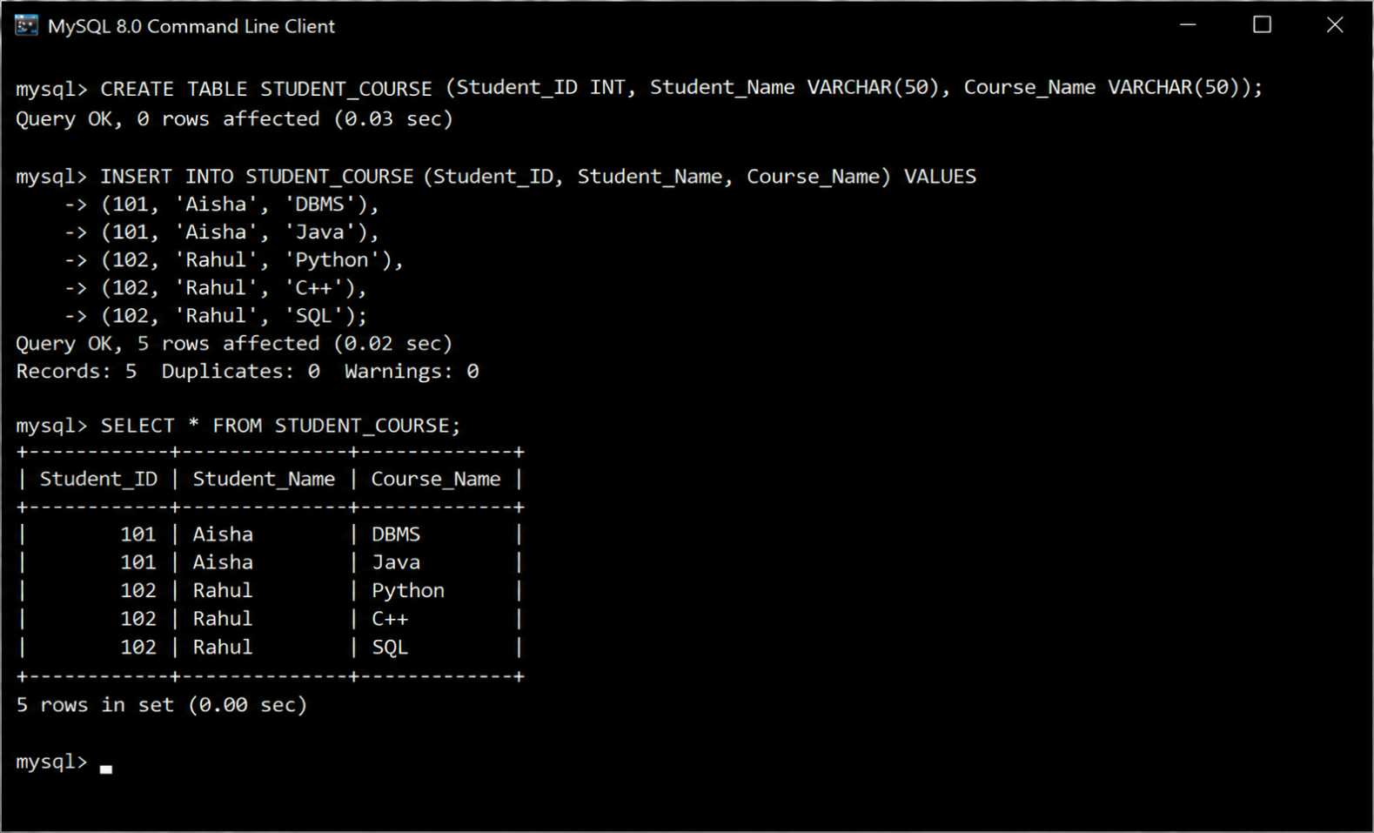

Explanation
- 1NF requires every column to contain a single value.
- The repeating group (DBMS, Java and Python, C++, SQL) is removed by storing each course in a separate row.
- This eliminates repeating groups and ensures the relation satisfies First Normal Form (1NF).

Final Correct Table
CREATE TABLE STUDENT_COURSE
(
Student_ID INT,
Student_Name VARCHAR(50),
Course_Name VARCHAR(50)
);
Expected Result
+------------+--------------+-------------+
| Student_ID | Student_Name | Course_Name |
+------------+--------------+-------------+
| 101 | Aisha | DBMS |
| 101 | Aisha | Java |
| 102 | Rahul | Python |
| 102 | Rahul | C++ |
| 102 | Rahul | SQL |
+------------+--------------+-------------+
Result: The relation is successfully converted to First Normal Form (1NF) by removing repeating groups and storing one course per row.

10.Identify redundant attributes in a relation and apply basic normalization (up to 3NF) to improve design.

Given Relation (Not in 3NF)
Student_ID | Student_Name | Department_ID | Department_Name
101 | Aisha | 1 | Computer Science
102 | Rahul | 2 | Information Technology
103 | Priya | 1 | Computer Science

Errors Identified
- Department_Name is stored repeatedly for students in the same department.
- Department_Name depends on Department_ID, not directly on Student_ID.
- This creates redundancy and may cause update anomalies.
- To achieve Third Normal Form (3NF), separate department details into a different table.

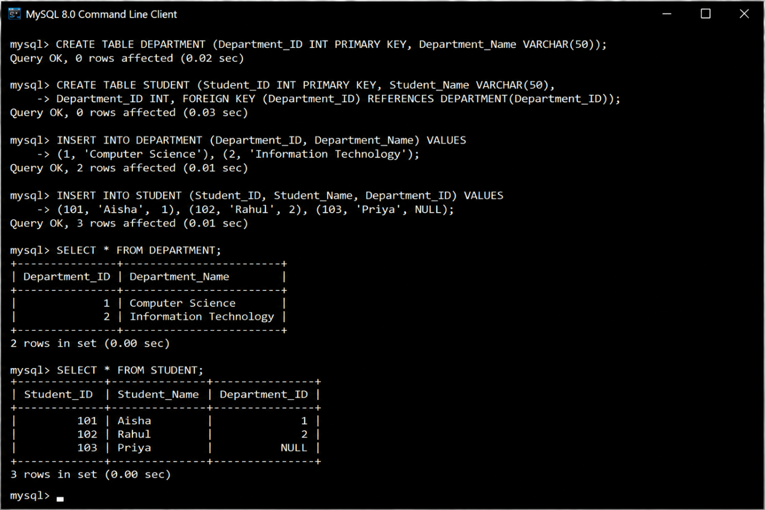

Explanation
- Department_Name is moved to a separate DEPARTMENT table.
- The STUDENT table stores only Department_ID, which references the DEPARTMENT table.
- This removes redundant data and eliminates insertion, update, and deletion anomalies.
- The database design now satisfies Third Normal Form (3NF).

Final Correct Queries
Create DEPARTMENT Table
CREATE TABLE DEPARTMENT
(
Department_ID INT PRIMARY KEY,
Department_Name VARCHAR(50)
);
Create STUDENT Table
CREATE TABLE STUDENT
(
Student_ID INT PRIMARY KEY,
Student_Name VARCHAR(50),
Department_ID INT,
FOREIGN KEY (Department_ID) REFERENCES DEPARTMENT(Department_ID)
);
Retrieve Student and Department Details
SELECT S.Student_ID,
S.Student_Name,
D.Department_Name
FROM STUDENT S
INNER JOIN DEPARTMENT D
ON S.Department_ID = D.Department_ID;
Expected Result
+------------+--------------+------------------------+
| Student_ID | Student_Name | Department_Name |
+------------+--------------+------------------------+
| 101 | Aisha | Computer Science |
| 102 | Rahul | Information Technology |
| 103 | Priya | Computer Science |
+------------+--------------+------------------------+
Result: The relation is normalized to Third Normal Form (3NF) by removing redundant attributes and storing department information in a separate table.

